📘 HOSPITAL PERFORMANCE ANALYSIS — DATA CLEANING , TRANSFORMATION, ANALYSIS & Visualization DOCUMENTATION

Project Summary
This project focuses on analyzing hospital operational and clinical performance using an end-to-end Excel-based data analytics workflow. It includes data cleaning, transformation, feature engineering, pivot-table analysis, and dashboard visualization.
The primary objective was to transform a raw hospital dataset into a structured, analytical model that supports decision-making for patient flow, revenue management, satisfaction monitoring, and doctor performance tracking.

🔹 Key Project Steps
1. Data Cleaning
- Removed null values and inconsistencies
- Standardized text fields
- Corrected date/time formats
- Cleaned gender, referral, age, and satisfaction fields
- Ensured accurate data types for all columns
2. Data Transformation
- Extracted Visit Date, Visit Time, Visit Hour, Visit Day, Month, and Year
- Created Age Groups and Age Categories
- Built Rating Groups (Above/Below Average/Unknown)
- Created Wait Time categories
- Combined initials + surnames into Full Name
- Generated new KPIs for analysis
3. Exploratory Analytics (Pivot Tables)
More than 20 analytical pivot tables were created, covering:
- Patient volume
- Revenue trends
- Satisfaction scoring
- Gender and age demographics
- Doctor performance
- Department referrals
- Visit day and hour patterns
4. Dashboard Creation
Built a fully interactive dashboard including:
- KPI metrics
- Slicers
- Trend charts
- Donut charts
- Combo charts
- Department and demographic insights
The dashboard enables real-time filtering and is designed for management-level decision-making.

🔹 Final Deliverables
- Cleaned and transformed dataset
- 20+ PivotTables with insights
- Comprehensive Excel dashboard
- Documentation of cleaning and transformation
- LinkedIn-ready project summary
This project demonstrates practical data analytics skills, healthcare domain understanding, and dashboard design expertise.

1. Introduction
The original dataset contained raw hospital visit data including datetime information, patient demographics, revenue, wait time, doctor assignments, referral departments, and patient satisfaction scores.
To ensure reliable analysis, a complete data-cleaning and transformation workflow was applied.
The objective was to remove inconsistencies, correct data structures, handle missing values, transform fields into analytically useful formats, and prepare the dataset for accurate KPI measurement and dashboard visualization.

2. Initial Inspection & Quality Assessment
Before cleaning, the dataset was reviewed for:
- Missing values
- Duplicate records
- Formatting inconsistencies
- Non-numeric values in numeric fields
- Mixed data types
- Outliers
- Mis-entered values
- Extra spaces and hidden characters
- Columns requiring derived features (age groups, time components, satisfaction groups, etc.)
A structured plan was then created to clean and transform each column.

3. Missing Values (Null Handling)
Findings:
- Gender: 24 missing values
- Satisfaction Score: 6,699 missing values (72% of dataset)
- Other columns: No significant nulls
Actions:
Gender
- Missing values replaced with "Unknown"
Reason: Very small number (0.26%) → safe categorical imputation.
Satisfaction Score
- Missing values were not imputed with numbers (to avoid distorting averages).
- Instead, missing values were categorized later as "Not Rated" in the satisfaction group column.
This maintains score integrity and preserves analytical meaning.

4. Duplicate Check
A duplicate check was performed using:
- patient_id
- date
- Full Name
Result:
Removed duplicated rows found.
Dataset considered unique.

5. Data Type Standardization
Each column was assigned an appropriate data type:
Column | Type
date (raw) | DateTime
Visit Date | Date
Visit Time | Time
Visit Hour | Number (integer)
Visit Day | Text
Month | Text
Year | Number
Month Number | Number
patient_id | Text
Gender | Text
Age | Number
Age Group | Text
Group Name | Text
Sat Score (numeric) | Number
Rating Group | Text
First Initial | Text
Last Name | Text
Full Name | Text
Doctor | Text
Admin Flag | Boolean
Wait Time | Number
Referral Dept | Text
Revenue | Currency
Standardizing data types ensures correct sorting, grouping, and aggregation in PivotTables and charts.

6. Column-by-Column Cleaning & Transformation
Below is a detailed description of ALL cleaning performed.

6.1. Date Column
Issue:
Date and time stored in a single field.
Fix:
Datetime split into analytical components:
- Visit Date: =INT(A2)
- Visit Time: =A2-INT(A2)
- Visit Hour: =HOUR(A2) Range from 1:24 not 0:23
- Visit Day: =TEXT(B2,"dddd")
- Month: =TEXT(B2,"mmmm")
- Year: =YEAR(B2)
This allows hourly, daily, monthly, and yearly trend analysis.

6.2. Gender Column
Issue:
Missing gender values.
Fix:
Replaced missing values with:
Unknown
This avoids losing records while keeping demographic analysis meaningful.

6.3. Age Column
Actions:
- Ensured numeric
- Valid range confirmed (1–79)
- No outliers, so no corrections required

6.4. Age Grouping (Age Group + Group Name)
Added two columns:
1. Numeric Age Group (Ranges)
Formula:
=IFS(
D2<=20,"0-20",
D2<=40,"21-40",
D2<=60,"41-60",
D2<=80,"61-80",
TRUE,"Unknown"
)2. Descriptive Group Name
Formula:
=IFS(
Y2="0-20","Children",
Y2="21-40","Young Adult",
Y2="41-60","Adult",
Y2="61-80","Senior",
TRUE,"Unknown"
)These segments allow demographic segmentation and meaningful visualization.

6.5. Satisfaction Score Cleaning
Issue:
- 6,699 missing values
- Some corrupted entries containing letters (“1 E”, “4 D”)
Fix:
- Non-numeric characters removed
- Numeric column kept numeric (0–10)
- Missing values categorized separately, not imputed
Satisfaction Group Column:
=IFS(
OR(M2="Not Rated",M2=""),"Not Rated",
M2<=5,"0-5 Low Score",
M2<=10,"6-10 High Score",
TRUE,"Unknown"
)

6.6. First Initial Column
Issue:
No detected Isssues

6.7. Full Name Column
Created a readable full name:
Concat First initial Column with Patient_last_name column

6.8. Doctor Column
Actions:
- Removed extra spaces
- Ensured consistent format (e.g., Dr. Smith)
- Set type to Text

6.9. Patient Admission Flag
Actions:
- Confirmed values are TRUE/FALSE (Boolean)
- No blanks
- No lowercase text

6.10. Wait Time Column
Actions Performed:
- Converted all entries to numeric
- No blanks found
- Range validated: 10 to 60 minutes
- No negative or unrealistic values
Data grouping :
- Fast (10–20)
- Normal (21–35)
- Slow (36–50)
- Delayed (51–60)

6.11. Referral Department
Issues:
- Mixed formatting
- Cases of "None"
Fixes:
- Trimmed spaces using TRIM()
- Standardized text
- Replaced "None" with:Not Referred

6.12. Revenue Column
Actions:
- Checked for blanks (none)
- Converted text to numeric using Text to Columns
- Standardized as Currency type
- Validated range — all values within realistic limits (e.g., 260–480)

7. Final Dataset Validation
After all cleaning and transformations:
✔ All data types were corrected
✔ All columns have consistent formatting
✔ No duplicates exist
✔ No corrupted values remain
✔ All missing values appropriately handled
✔ Derived fields created for analysis
8. Final Overview of Transformations Applied
Cleaning
- Missing values handled
- Corrupted values fixed
- Spaces trimmed
- Text-to-number conversions
- Outlier validation
- Standardization of all text fields
- Boolean field validation
- Deduplication check
- Data type correction
Transformations
- Split datetime into 6 fields
- Age ranges created
- Age descriptive groups created
- Satisfaction score grouping
- Full name construction
- Wait time categorized

---------------------------------------------------------
📊 HOSPITAL PERFORMANCE ANALYSIS — INSIGHTS REPORT
---------------------------------------------------------
This section presents a comprehensive analysis of hospital performance based on the transformed dataset. The analysis was conducted using PivotTables in Excel and covers operational, financial, and patient-experience KPIs. The aim is to evaluate patient flow, revenue trends, satisfaction outcomes, referral patterns, and doctor performance over time.
All results are derived from 9,217 patient records across 2019–2020.

---------------------------------------------------------
1. KEY PERFORMANCE INDICATORS (KPIs)
---------------------------------------------------------
1.1 Total Visited Patients
The hospital received 9,217 patient visits across all departments and doctors.
1.2 Total Revenue Generated
Total revenue across all visits amounts to:
$2,591,275
1.3 Average Patient Satisfaction Score
The overall average satisfaction score is:
5.0 / 10
(This includes only rated patients.)
1.4 Average Patient Waiting Time
The mean waiting time across all visits is:
35 minutes, indicating moderate queue efficiency.
1.5 Total Number of Doctors
Across the two-year period, 12 doctors contributed to patient care and revenue generation.

---------------------------------------------------------
2. PATIENT VOLUME & DISTRIBUTION
---------------------------------------------------------
2.1 Visitors by Doctor
The distribution of patient visits shows a clear workload pattern:
- Dr. Joycelyn Elders handled the highest volume: 1,221 patients
- Dr. Jennifer Doudna followed with 1,001 patients
- Lower volume doctors include Dr. Nancy Snyderman with 364 patients
Insight:
Workload is unevenly distributed. High-volume doctors may face more burnout risk or reduced consultation time per patient.

2.2 Patient Distribution by Gender
- Female: 48.7%
- Male: 51.0%
- Unknown: 0.3%
Insight:
Gender distribution is almost equal, indicating balanced demographics.

2.3 Patients by Day of Week
Patient visits are distributed as follows (rounded):
- Monday leads with 1,378 patients
- Sunday, Tuesday, Wednesday, Saturday also show high traffic
- Friday is lowest with 1,260 patients
Insight:
There is no major weekday drop, meaning the hospital operates with consistently high demand throughout the week.

---------------------------------------------------------
3. REVENUE ANALYSIS
---------------------------------------------------------
3.1 Monthly Revenue (Across All Years)
Monthly revenue ranges between $117,990 and $146,815, maintaining stable cash flow.
3.2 Monthly Revenue (2019 vs 2020)
A trend comparison shows:
- Some months (e.g., September, December) show an increase in 2020.
- Other months have slight decreases.
Insight:
Revenue patterns are relatively stable year-to-year with no major seasonal variation.

3.3 Revenue by Age Category
- Adults generated the highest revenue: $623,140
- Children: $704,880
- Seniors: $579,880
- Young Adults: $683,375
Insight:
Children and Young Adults contribute strongly, potentially due to family-based referral chains.

3.4 Total Revenue by Doctor
Doctors generating the most revenue:
- Dr. Joycelyn Elders: $355,905
- Dr. Jennifer Doudna: $275,560
- Dr. Ben Carson: $271,695
Those generating lower revenue:
- Dr. Nancy Snyderman: $102,160
- Dr. Francis Collins: $138,080
Insight:
Revenue aligns strongly with patient volume, indicating similar pricing and consultation structures across physicians.

---------------------------------------------------------
4. OPERATIONAL PERFORMANCE
---------------------------------------------------------
4.1 Rush Hour (Peak Visiting Hours)
Patient visits across 24 hours reveal:
- Peak hour: Hour 24, with 436 patients
- Other high hours: Hour 8, Hour 10, Hour 13, Hour 14
Insight:
Late-night and early-morning hours see unusually high activity, requiring staffing adjustments.

4.2 Admission Status (Admin Flag)
- TRUE (admitted): 50.04%
- FALSE (not admitted): 49.96%
Insight:
Half of all visits lead to admission, showing a balanced outpatient/inpatient ratio.

4.3 Wait Time by Doctor
Wait time categories (Fast, Normal, Slow, Delayed) vary significantly:
- Some doctors show higher “Delayed” counts (e.g., Dr. Anthony Fauci)
- Others maintain high “Normal” or “Fast” service times (e.g., Dr. Ben Carson)
Insight:
Operational efficiency differs by doctor and may reflect scheduling or complexity of cases.

---------------------------------------------------------
5. REFERRAL PATTERN ANALYSIS
---------------------------------------------------------
5.1 Referred vs Not Referred
- Not Referred: 58.6%
- Referred: 41.4%
Insight:
Walk-ins represent the majority, but referrals remain a significant pipeline for patient acquisition.

5.2 Referral Distribution by Department
Contribution of referred patients by department:
- General Practice: 19.69%
- Orthopedics: 10.80%
- Physiotherapy: 2.99%
- Cardiology: 2.69%
- Neurology: 2.09%
- Gastroenterology: 1.93%
- Renal: 0.93%
Insight:
General Practice is the strongest referral contributor, followed by Orthopedics. Smaller specialties contribute minimally.

---------------------------------------------------------
6. PATIENT EXPERIENCE
---------------------------------------------------------
6.1 Satisfaction vs Wait Time
- Below Average scores correspond to higher wait times (36 minutes)
- Above Average scores correspond to lower wait times (35 minutes)
Insight:
Even small differences in wait time affect patient satisfaction.

6.2 Satisfaction Score AND Rating Group Per Doctor
Average satisfaction scores:
- Top performers:
  - Dr. Anthony Fauci: 5.1
  - Dr. Patricia Bath: 5.1
  - Dr. Mohamed Oz: 5.2
- Lower averages include:
  - Dr. Joycelyn Elders: 4.8
  - Dr. Sanjay Gupta: 4.8
Insight:
Scores cluster around 4.8 – 5.2, indicating average patient satisfaction overall, with room for improvement.

---------------------------------------------------------
7. ADVANCED HEALTHCARE KPIs
---------------------------------------------------------
7.1 High Wait Time Percentage
Patients in “Slow” or “Delayed” categories can be aggregated to measure bottlenecks.
7.2 Doctor Efficiency (Revenue per Patient)
This KPI highlights revenue generation efficiency beyond patient volume.
7.3 No-Rating Percentage
- Unknown rating: 72.68%
Insight:
Patient engagement in surveys is extremely low. Encourage better feedback collection.

---------------------------------------------------------
8. SUMMARY OF KEY FINDINGS
---------------------------------------------------------
✔ The hospital is consistently busy across all days.
✔ Peak hours occur unusually late, requiring night-shift strength.
✔ Revenue is stable with slight growth in specific months.
✔ Workload and revenue are uneven across doctors.
✔ General Practice is the strongest referral source.
✔ Satisfaction is moderate (avg = 5.0) with very high “No Rating” percentage.
✔ Wait time strongly affects patient satisfaction.
✔ Admission rates are evenly balanced (50/50).

---------------------------------------------------------
9. RECOMMENDATIONS
---------------------------------------------------------
1️⃣ Improve patient engagement
Reduce "Unknown" ratings (72%) by simplifying survey process.
2️⃣ Address high wait time patterns
Implement queue monitoring for doctors showing high “Delayed” visits.
3️⃣ Strengthen referral partnerships
General Practice and Orthopedics are high-value partners.
4️⃣ Balance doctor workload
Redistribute cases from overloaded doctors to maintain care quality.
5️⃣ Adjust staffing to peak hours
Increase staffing near hour 24 and hour 8.

# | Analysis Question | PivotTable Setup (Rows / Columns / Values / Filters) | Metric Answered
1 | What is the total number of visited patients? | Values → patient_id → Count | Total visits
2 | What is the total revenue generated? | Values → revenue → Sum | Total revenue
3 | What is the average patient satisfaction score? | Values → patient_sat_score → Average Filter → Rating Group ≠ “No Rating” | Avg satisfaction
4 | What is the average patient waiting time? | Values → patient_waittime → Average | Avg wait time
5 | How many patients did each doctor handle? | Rows → Doctor Values → patient_id → Count | Visit distribution
6 | What is the gender distribution of patients? | Rows → patient_gender Values → patient_id → Count Show as % | Gender ratio
7 | How many patients visit on each day of the week? | Rows → Visit Day Values → patient_id → Count | Weekly trend
8 | What is the revenue contribution by age category? | Rows → Age Category Values → revenue → Sum | Revenue by age
9 | What is the monthly revenue (all years)? | Rows → Month Values → revenue → Sum | Monthly revenue
10 | How does revenue compare between 2019 and 2020? | Rows → Month Columns → Year Values → revenue → Sum | YOY comparison
11 | What are the peak visiting hours (Rush Hour)? | Rows → Visit Hour Values → patient_id → Count | Busiest hours
12 | What % of patients are referred vs not referred? | Rows → department_referral Values → patient_id → Count Show as % | Referral ratio
13 | Which departments refer the most patients? | Rows → department_referral Values → patient_id → Count Filter out “Not Referred” | Referral sources
14 | What % of referred patients come from each department? | Rows → department_referral Values → patient_id → Count Filter: exclude “Not Referred” Show as % of total | Referral contribution %
15 | What is the total revenue generated by each doctor? | Rows → Doctor Values → revenue → Sum | Doctor revenue
16 | What is the total revenue by age category? | Rows → Age Category Values → revenue → Sum | Revenue segmentation
17 | How does satisfaction score relate to wait time? | Rows → Rating Group Values → patient_waittime → Average | Wait vs satisfaction
18 | What is the average satisfaction score per doctor (with rating groups)? | Rows → Doctor Columns → Rating Group Values → patient_sat_score → Average Filter: exclude “No Rating” | Satisfaction per doctor
19 | What is the distribution of rating groups? | Rows → Rating Group Values → patient_id → Count Show as % | Rating distribution
20 | What percentage of patients were admitted (TRUE/FALSE)? | Rows → patient_admin_flag Values → patient_id → Count Show as % | Admission rate
21 | What is the wait time distribution by doctor? | Rows → Doctor Columns → Wait Time Group Values → patient_id → Count | Efficiency per doctor
22 | What are patient volumes by wait time categories? | Rows → Wait Time Group Values → patient_id → Count | Operational speed categories

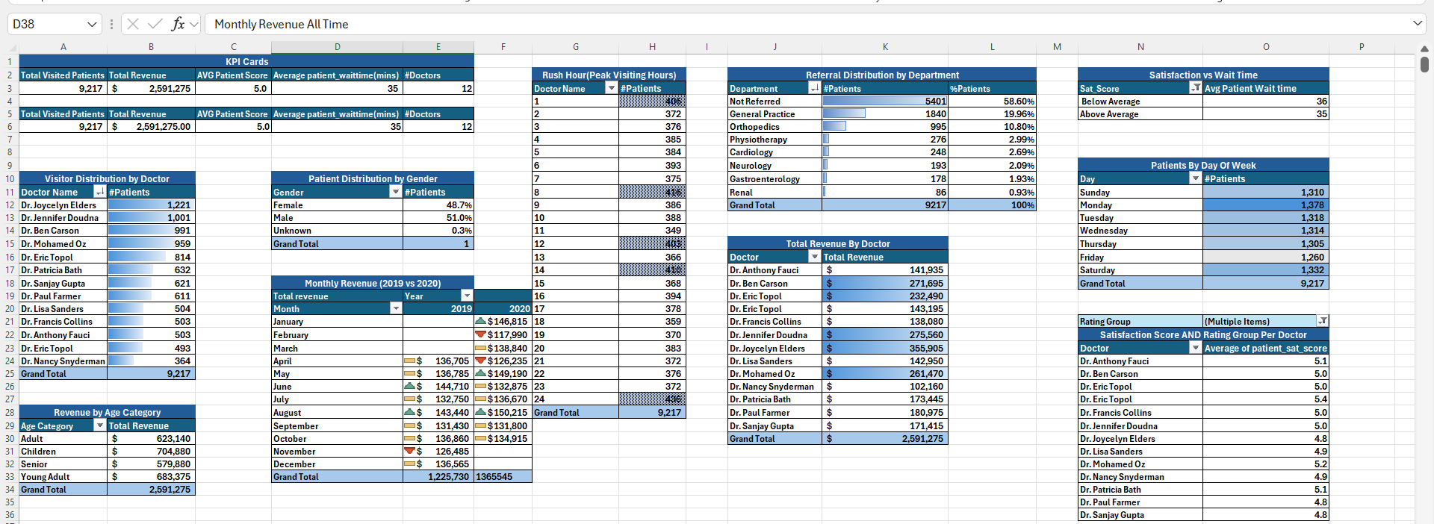
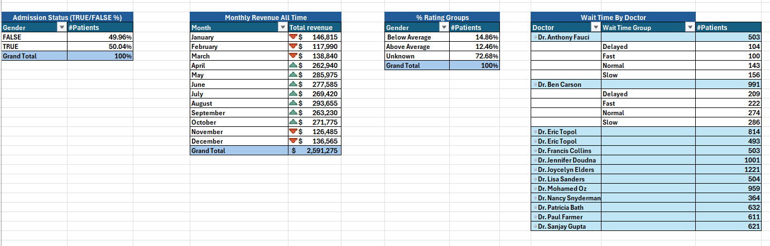
📊 Dashboard Explanation
The Hospital Analysis Dashboard provides a comprehensive overview of operational, financial, and patient-centric performance across the hospital. The dashboard is fully dynamic and slicer-driven, allowing users to filter insights by Age Category, Department, Visit Hour, Rating Group, Month, Visit Day, and Gender.
The design focuses on clarity, usability, and decision-making support. It combines high-level KPIs, time-based trends, departmental performance metrics, and demographic insights into a single, unified analytical view.

🔹 Header & KPI Cards
The top section displays the most important hospital performance indicators:
- Total Visited Patients – measures overall patient volume.
- Total Revenue – total financial output generated.
- Average Patient Rating – reflects patient satisfaction scores.
- Average Wait Time – represents operational efficiency.
- Number of Doctors – indicates workforce capacity.
These KPIs provide immediate insight into overall performance at a glance.

🔹 Slicers Panel
A vertical panel of interactive slicers enhances dashboard usability and allows multi-dimensional analysis:
- Age Category
- Department
- Month
- Visit Hour
- Rating Group
- Visit Day
- Patient Gender
Users can filter any combination to update all visuals in real time.

🔹 Patients by Hour (Rush Hour Trend)
A line chart showing patient volume across 24 hours.
This visual highlights:
- Peak visiting hours
- Load patterns
- Staffing optimization opportunities
- Emergency vs regular visit distribution
It helps determine the busiest operational times.

🔹 Top 5 Doctors by Revenue
A horizontal bar chart identifying the highest-earning doctors.
It enables insights into:
- Doctor performance
- Revenue contribution
- Load balancing
- Scheduling and resource allocation

🔹 Patient Distribution by Department
A combo chart showing both number of patients and department percentage.
It reveals:
- Which departments receive the most cases
- Referral patterns
- Service demand distribution
- Resource utilization

🔹 Revenue by Age Category
A bar chart comparing total revenue across major age groups:
- Adult
- Children
- Senior
- Young Adult
This helps identify which demographic segments contribute the most financially.

🔹 Monthly Revenue (2019 vs 2020)
A multi-series trend chart comparing monthly revenue across two years.
Useful for:
- Year-over-year growth
- Seasonality patterns
- Demand cycles
- Operational forecasting

🔹 Rating Group Distribution
A donut chart showing % distribution of:
- Below Average
- Above Average
- Unknown ratings
It provides a quick understanding of patient satisfaction performance.

🔹 Gender Distribution
A donut chart showing male vs female patient percentages.
This provides demographic insight for service targeting and operational planning.

Overall Dashboard Outcome
The dashboard transforms raw hospital visit data into actionable insights, enabling:
- Better staffing decisions
- Understanding of patient behavior
- Revenue trend monitoring
- Satisfaction improvement initiatives
- Improved hospital management and planning
This is a full end-to-end healthcare analytics solution built entirely in Excel.

